**4Tune**

**April 2013 v1**

LEGAL NOTICE

*ASU30*

*ASU30 and ATUU30 are acronyms for Adult Smoker Under 30 and Adult Tobacco User Under 30. The term ‘adult’ is defined by local law, but shall in no circumstance refer to any person under the age of 18. Likewise, consistent with BAT’s International Marketing Standards, terms such as ‘consumer’, ‘target consumer’, ‘smoker’, or ‘target audience’ refer only to smokers whom are adults.*

LOCAL LEGISLATION / REGULATIONS

*The material contained in this document may present executions and themes that are not legally permissible or acceptable in some markets. Likewise, because tobacco regulation and the company’s own views on socially responsible marketing change over time, previously approved activities may no longer be permissible. Therefore, you must obtain local legal and CORA approval before proceeding with any activity in your market.*

*COPYRIGHT AND CONFIDENTIALITY*

*© British-American Tobacco (Holdings) Limited 2013. All rights reserved. No part of this document may be reproduced in any form or any means without the prior written consent of British-American Tobacco (Holdings) Limited (˝BAT˝).*

*This document is proprietary to BAT and is provided to employees of the BAT Group and certain trusted contractors working for a member of the BAT Group. It is disclosed solely for use by employees in the course of their employment or by contractors for the purpose of facilitating the provision of services by that contractor to the employing BAT company and for no other purposes. Unauthorised possession or use of this material or disclosure of the proprietary information without the prior written consent of BAT may result in legal action.*

*THIRD PARTY TRADEMARKS*

*“Trademarks, logo designs and/or brand names featured in this material and not owned by British American Tobacco PLC (or one of its group companies) are owned by the relevant proprietor of the particular trademark and/or brand name in question, and are referred to in this document for informational and/or illustrative purposes only.”*

Contents

1. Overview – 4Tune Study: 3

2. How to set up a 4Tune Study? 6

2.1 Design considerations: 6

2.2 Design Examples: 8

2.3 Sample Size and type: 9

2.4 Target Group: 10

2.5 Stimulus materials and requirements: 10

2.6 Interview location and requirements: 11

3. The Interview and Questionnaire flow 12

3.1 Interview Flow: 12

3.2 Questionnaire flow and information areas: 13

4. Key Metrics and Analytics 15

4.1 Action Standard Setting: 15

4.2 Key Deliverables: 16

5. Agency for 4Tune 17

# Overview – 4Tune Study:

4Tune is part of the new BAT 4Suite Innovation Testing toolkit. This tool has been designed as a late stage offer test to select the optimum mix combination and to finalise the launch manifesto. The tool prioritises mix element options based on offer potential and provides and overall assessment of the strength of the marketing mix. 4Tune can also be used to test changes to a single element of the mix (for instance packaging) and to test the strength of the proposed mix against the current or competitive offer.

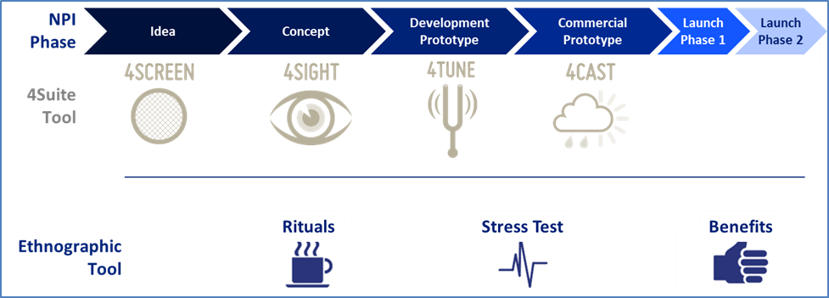

The tool has two main designs answering the following key business questions:

1. **What is the optimal offer mix for launch? –** *to be addressed through 4Tune Mix Optimiser*
2. **What is the health of my mix for an existing offer in the market? –** *to be addressed through**4Tune Total Offer Dipstick*

**4Tune Mix Optimiser**

This design will provide a flexible and efficient approach to evaluate and rank multiple mix element options (packs, sticks or communication of an existing offer or a new offer). The testing is done with the principle of a Total Offer Evaluation – i.e. the respondent is shown the entire mix to evaluate rather than testing individual mix elements in isolation. This new tool replaces the previous Total Offer Test (TOT) and Pack Test (PT).

4Tune Optimiser has a set of core indicators embedded that will help to understand the relative appeal of each mix option against each other. Respondents will evaluate different options for a specific mix element (other elements remaining constant) – for instance 3 different pack options of a BAT brand.

The outcome of 4Tune is a potential index - a preference share - that will show both the ranking of the offers and the distance between them.

In principle 4Tune is designed to be a tool to optimise the BAT brand mix (to select the best one out of the presented options) and therefor competitive benchmarking is not a standard component of the test. If there is a special reason to compare the BAT mix to a competitor mix from a mix coherence or health perspective – it is possible to add a separate panel to the study that measures the competitor brand offer. The necessity and usefulness of adding the competitor should be carefully considered.

Please note that the preference share does not correlate to market share potential. The offers are tested within limited target groups in a perfect simulated environment with a limited product exposure. However rather than only ranking the offers 4Tune will give an *indication and sense of the size of opportunity.*

4Tune includes a 1-stick smoking experience to complete the total offer exposure and a good overall view of the test offer.

4Tune should always include the 1-stick test – however in cases where there are legal restrictions for smoking during consumer research 4Tune can be done without the product experience concentrating on the remaining mix elements. These special cases require a sign-off from Global Oracle Manager.

4Tune Mix Optimiser is not a mandatory research within the innovation development pipeline – it is optional across Cap3-2-1 projects but should be used where mix optimisation is needed.

4Tune Mix Optimiser can be used for a wide range of mix optimising projects by the markets where changes are planned for the existing offers in the market.

**4Tune Total Offer Dipstick**

4Tune Total Offer Dipstick test is designed to evaluate the health of an existing brand mix in the market to understand the effectiveness of the different mix elements. The BAT brand mix can also be tested against a competitor brand mix.

4Tune Total Offer Dipstick is rather similar to the earlier Total Offer Test (TOT) where one full offer is evaluated to understand the health of the mix elements.

Please note that 4Tune Total Offer Dipstick does not provide a share estimate – as a single offer test the purpose is to understand the diagnostics and the strength of the mix combination. 4Tune should not be used as a replacement for a 4Cast study.

.

# How to set up a 4Tune Study?

4Tune is a quantitative test that can be done with a Sequential Monadic design when testing mix options for a single brand. For mix optimisation this design brings efficiency compared to the earlier TOT design and adds a more robust and real-market like total offer evaluation compared to the earlier pack test. In essence 4Tune combines the best out of both approaches into one single test.

As 4Tune can be used to test a wide range of different mix optimisation and mix health scenarios it is very important to review thoroughly the objectives and the available/planned stimuli with the research agency right in the beginning as these have an impact on the study design.

## Design considerations:

* 4Tune Mix Optimiser can accommodate between 2-5 mix options for a single mix element. For instance test 2-5 different pack options whilst the rest of the mix remains constant. The limitation is linked to both the interview length and also the respondent fatigue. If there are more than 5 options to be tested the recommendation is to first run a shortlisting (internal and possibly external) or then to setup a matched panel with one common offer across the panels.
* Within one panel only one mix element should be the changing variable. If there is more than one mix element that has multiple options – For instance there are multiple options for a pack and for a stick – this requires setting up matched panels to review the different options.
* There needs to be a reasonable balance within the test for the offers that are shown in Sequential Monadic manner. For instance if we are testing 4 packaging options where 3 are rather similar with each other (for instance red colour) and one is completely different (for instance white colour) setting all in one panel would be likely to bias the evaluation of the single white pack. In this particular case a Monadic Approach would be recommended. Due to this it is crucial that the stimulus materials are discussed in detail with the research agency right in the first planning phase. The nature and looks of the options may have a considerable impact on the design, cost and timings.
* If there is a plan to replace a current offer in the market – for instance upgrade the packaging of an existing offer – the current offer needs to be included in the test as a benchmark.
* We can only place one brand within one panel. 4Tune is designed to evaluated mix options for one Brand range. If there is a need to include into the study a comparison to another range *(For instance Kent Nanotek versus Kent HD)* or to another brand, these have to be separated to a matched panel.
* As 4Tune uses the total offer approach a 1-stick test is in principle required to complete each offer evaluation. However in practice it is not feasible to ask one respondent to smoke more than 3 cigarettes during the course of one interview. In such cases each respondent will be asked to evaluate 3 offers in full including the 1 stick test and 2 offers without the 1 stick test. The first 3 offers tested will have the 1 stick evaluation and the next 2 will be only evaluated for the key metrics without the 1-stick placement. All offers are fully rotated within the sample to provide in the end 150 respondents who have fully evaluated the offer.
* The 1 stick test is an important part of the full evaluation. It helps to understand the test option performance against the expectations that were initially set prior to the product experience.
* The product must always remain the same within one panel. However, respondents are not told that the product is the same. This helps to identify if changing the mix element – for instance stick design – has an impact on the product’s taste perception and the overall evaluation of the offer. If the objective of the study is to get detailed information on the product per se or test different products – the right design is likely to be a Branded Product Test (BPT) or a 4Cast.
* If 4Tune is administered in a market where it is not legally possible to do any product testing – the test can be done without the product experience for the partial mix. This is not an ideal design and it will deliver a ranking and potential indication that is based on assumed product performance and consumer expectations. The outcome of such study will be a *Trial Potential Index.* The use of such 4Tune design will require the sign-off from Global Oracle Manager.
* If the mix element that is evaluated is the Price – it is possible to setup a 4Tune study with monadic panels to test one price against another to see which mix gives a higher potential. However what needs to be considered carefully is whether the better option at this point would be the 4Cast study. If all other mix elements are ready and decided the 4Cast study gives a much more robust base for making a pricing decision.

## Design Examples:

|  |  |  |  |  |
| --- | --- | --- | --- | --- |
| **Case** | | **Design** | **Note(s)** | |
| **4 pack/comms options to be tested where all options are similar to each other**  *e.g. say all pack options are in different shades of dark red* | **Single panel with sequential monadic design** | | | **Similar logic to be followed for packs differentiated in terms of shade/tone of background colour, design elements, crest or logo** |
| **4 pack/comms options to be tested where 2 are similar between each other and the other 2 are also similar between themselves**  *e.g. 2 pack options are in similar shades of red and the other 2 are in similar shades of white* | **Single panel with sequential monadic design** | | |  |
| **4 pack/comms options to be tested where each option is distinctly different**  *e.g. All pack options are different in terms of pack colour* | **Single panel sequential monadic design if**  **For new launch, none of the colors are similar to that of an existing variant of the brand house**  **For re-launch, none of the colors are similar to that of an existing variant of the brand house** | | | **Each pack option separately in matched monadic panels if**  **For new launch, 1 or more options is similar to an existing variant of the brand house**  **For re-launch, 1 or more options is similar to the existing offer** |
| **4 pack/comms options to be tested where one or more (but not all) is distinctly different from the others**  *e.g. 3 packs are in shades of dark red and 1 is in white* | **Each pack option separately in monadic panels matched on smoker graphics and demographics** | | | **Due to sequentially monadic design, this would create bias** |

For **4Tune Total Offer Dipstick**, design and methodology considerations will be very similar to Total Offer Test (TOT). The study will be conducted in separate monadic panels for each of the offers tested. As the objective of the test is to review the mix health for an existing offer the questionnaire has a longer set of questions for each mix element to understand in detail how they work.

Please note that the 4Tune Total Offer Dipstick is not meant for testing potential for new launches.

## Sample Size and type:

The sample size for the 4Tune Mix Optimiser depends on the number of options evaluated. The basic rule is that each option needs to be fully evaluated by at least 150 respondents. Therefore if we have 2 or 3 options which are fully evaluated (including one stick test) the sample size is minimum 150. If we have 4 options the sample size required is 200. For 5 options the sample size required is 250.

The principle here is that for each option there will be 150 evaluations which are treated separately and matched with each other in terms of socio-demographics and smoker-graphics. So in essence we are generating a number of pseudo-monadic matched panels from one Sequential Monadic panel.

If we are using a monadic design the minimum sample size for each panel is 150. This applies for both the 4Tune Mix Optimiser and the 4Tune Total Offer Dipstick.

Any additional reporting heads and boosters need a minimum sample size of 150.

## Target Group:

4Tune Mix Optimiser test should be deployed among a selected target group whose opinion matters when making a decision on mix elements. All market representation is not required here as the method will not be used for market share projection. However once we have specified the target group the design needs to ensure that we have at least 80% coverage of it within the sample considering also a good spread across demographic and geographic factors.

Same principle applies also to the 4Tune Total Offer Dipstick – the evaluation can be done among selected target consumers or if needed the entire franchise can be included.

4Tune test is less sensitive to the variation of the target group so the setup can be used flexibly to address objectives – unlike study like 4Cast where it is essential to be very careful about the representation in order to use norms and to provide a good quality share projection.

## Stimulus materials and requirements:

4Tune study requires the entire offer to be presented to the respondent to ensure a good overview of the total offer in the way consumer would find it in a market.

4Tune requires the following stimulus materials:

* **Communication board** – either printed or electronic (CAPI)
* **Price –** The price should be clearly mentioned for the offer
* **Actual branded pack/s or mock-up packs** if not possible to produce these then high quality 3D electronic mock-ups or raised boards can be used as well. It is important that the respondent has a good touch and feel of the packaging and understands properly the shape and the size.
* **Actual branded product**– for the 1-stick trial

*All stimulus materials must always comply with the local legislation and must be approved by the local Cora/Legal before starting the research.*

For the 4Tune Total Offer Dipstick the mix elements currently existing in the market would be used for the testing.

It is very important to review the feasibility and the availability of the stimulus before starting to plan for the test and to right away discuss any stimulus material limitations with the research agency. The amount and type of stimuli has big potential implications on the study design, cost and timings.

## Interview location and requirements:

It is recommended that the 4Tune interviews are conducted in a central location due to easier logistics and potential confidentiality issues.

Recruitment will be based on a set quota and will be then followed by the main interview.

The amount of central locations required for the test varies per market and by the nature and type of target group. The amount of central locations has an impact on the stimulus material requirement, cost and timing so it is important to discuss these options in advance with the research agency.

As data collection method CAPI is recommended to ensure correct rotation within the interviews especially in case of various options being tested. PAPI is technically possible but should be only used if no other alternative exists. If PAPI is used extra fieldwork controls need to be put in place to control the correct rotation.

If electronic stimulus is used it is very important that the coordinating agency reviews at an early stage what sort of computers the fieldwork agency has in use. If there is any risk of bad quality computer screens that may devaluate the quality of the electronic stimuli we need to either revert to printed materials or alternatively discuss with the coordinating agency on the feasibility of arranging computers for the fieldwork agency to use.

# The Interview and Questionnaire flow

4Tune is a single visit test with pre-recruited consumers. Typically the consumers are first recruited by using various methods and quota sampling – after which the suitable consumers are invited to the central location interview.

4Tune interview takes about 45 minutes to 1 hour depending on the number of options being tested.

## Interview Flow:

Brand Awareness, Usage & Disposition

* + The respondent will be asked a few questions regarding the brands existing in the market. The purpose is to find out if the respondent has any pre-disposed attitude towards the test brand house.

Proposition Exposure

* + The total offer is presented to the respondent
  + The offers are rotated as per the specific mix element under evaluation (i.e. either pack/ stick/ communication)
  + The price should be clearly mentioned at the time of the offer exposure (can be shown via separate price card)

Offer Evaluation (Pre Trial)

* + The respondent will answer a set of core questions on the total offer
  + Special focus on the mix element that is being evaluated

1-Stick Smoking Experience

* + The stick should be branded and the final product intended for the market. *(All products need to be the same)*
  + The respondent does not have to smoke the entire cigarette – they should be asked to smoke minimum 8 puffs. If respondent wants to smoke the entire cigarette sufficient time needs to be allocated for that.

Offer Evaluation (Post Trial)

* + The respondent will answer a set of questions on the total offer

Direct Comparison Ranking section

* + Once all the options have been sequentially tested as per rotation (following the above three stages for each mix option), a direct ranking exercise will be carried out
  + Respondents will be shown all the options again simultaneously and asked to rank them.
  + This will be followed by open question to probe for the reason for likes (for first ranked option) and dislikes (for last ranked option)

If more than 3 options are evaluated the 4th and 5th options for each respondent (in rotated manner) will be evaluated with a shorter questionnaire and without the 1-stick smoking experience. For the limited evaluation only Purchase Intention, Overall Appeal and Key Mix Element rating are asked.

## Questionnaire flow and information areas:

1. **SCREENER**

|  |  |
| --- | --- |
| **Section** | **Question** |
| **SCREENER** | Gender |
| Center |
| Age Screening (Exact Age) |
| Age Screening (2) |
| Trade / profession screening |
| Whether participated in market research |
| Whether participated in tobacco research |
| Smoke cigarettes daily |
| Average daily consumption |
| Regular brand |
| Time with regular brand |
| Demographic questions to be included as per market needs |
| Occasional brands |
| Regular brand disposition |

1. **MAIN INTERVIEW**

|  |  |  |
| --- | --- | --- |
| **Section** | | **Question** |
| **BRAND AWARENESS, USAGE & DISPOSITION** | | Regular brand reconfirmation |
| Prompted awareness |
| Trial in last 3 months |
| Evoke set formation |
| Image ratings of Regular brand House, Test brand House and Key competition |
| **REPEATED FOR EACH OFFER** | **PRE SMOKE EVALUATION** | Purchase intention |
| Image ratings of the offer |
| Modular imagery question (depending on which is the mix element under evaluation) |
| Overall appeal of the offer |
| **POST SMOKE EVALUATION** | Purchase intention |
| Purchase as regular / occasional / rarely |
| Image ratings of the offer |
| Overall appeal of the offer |
| **RANKING SECTION** | | Ranking of the offers |
| Likes of offer ranked best |
| Dislikes of offer ranked worst |

|  |  |
| --- | --- |
| **MODULAR QUESTIONS** | |
| **PACK MODULE** | Module for image ratings for pack |
| **STICK MODULE** | Module for image ratings for stick |
| **COMMUNICATION MODULE** | Module for image ratings for communication |

In case of 4Tune Total Offer Dipstick, full evaluation of each mix element will be done at Pre-Trial level. After product experience only key measures will be recorded to see whether product experience has any impact on the ratings.

# Key Metrics and Analytics

## Action Standard Setting:

4Tune test works in a relative manner – ranking or comparing presented offers against each other. The only exception to this is the 4Tune Total Offer Dipstick which can be used to diagnose the health of a mix for an existing product in the market.

For the 4Tune Mix Optimiser the key output measure is a relative potential index. The action standards should be set on achieving a similar or significantly higher index for the winning offer with 95% confidence level. In general a 10% higher index can be considered significant.

*For instance if the objective is to upgrade packaging – action standard could be set as follows: “Winning offer has to get at least 10% higher Preference Share than the Current offer in order to be selected”. Let’s say we have tested current + 2 new offers and the results come out as follows: Current offer – 100, New offer A – 104, New offer B – 116*

*The offer A is only 4% better than the Current offer and therefore not significant. The offer B is 16% better than the Current offer – this is significant and meets the action standard.*

It is also possible to place secondary action standards to achieve parity / superiority on specific attributes however it is recommended to keep these to the minimum and only use one attribute that is essential for the project. Adding several attributes as secondary action standards will complicate the study and decreases the likelihood of finding a winning offer.

In the 4Tune Total Offer Dipstick design no action standards are required as the test is exploratory to understand the mix health diagnostics.

## Key Deliverables:

Key deliverables from a 4Tune Mix Optimiser can be classified into the following two areas:

1. Relative potential index between the different mix options
2. Diagnostics of mix elements performance

**Potential Index:**

The Potential Index is calculated based on the Trial x Repeat model. The estimates of trial and repeat purchase probabilities are derived from the purchase intention questions pre and post product experience.

Any potential over-claim is calibrated using a Cultural Coefficient and selected imagery parameters.

This base will be then used to derive the Potential Index for each offer. This index is done under perfect conditions and assumes a 100% awareness, distribution and availability. It is important to note that the potential index is not comparable to volume share potential.

If design test does not include a 1-stick trial – then the outcome will be Trial Potential. The index in this case is based on only Trial probability without any product experience.

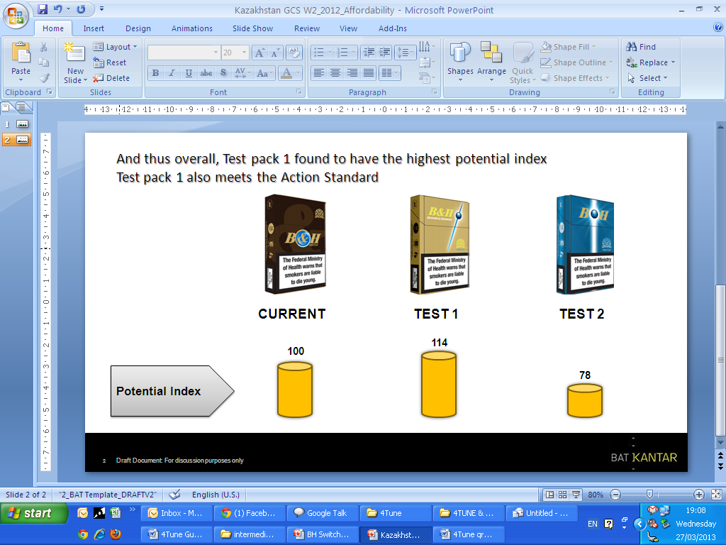

**Diagnostics of mix element performance:**

In the mix diagnostics analysis the purpose is to see how the offer performs at an overall level with specific focus on the mix element that is being evaluated (For instance the packaging).

Each mix element is reviewed and rated on the key parameters and in addition to this open ended questions are used to find out likes and dislikes. Finally the different offers are compared to each other in terms of the mix elements to see whether there are significant differences between the ratings.

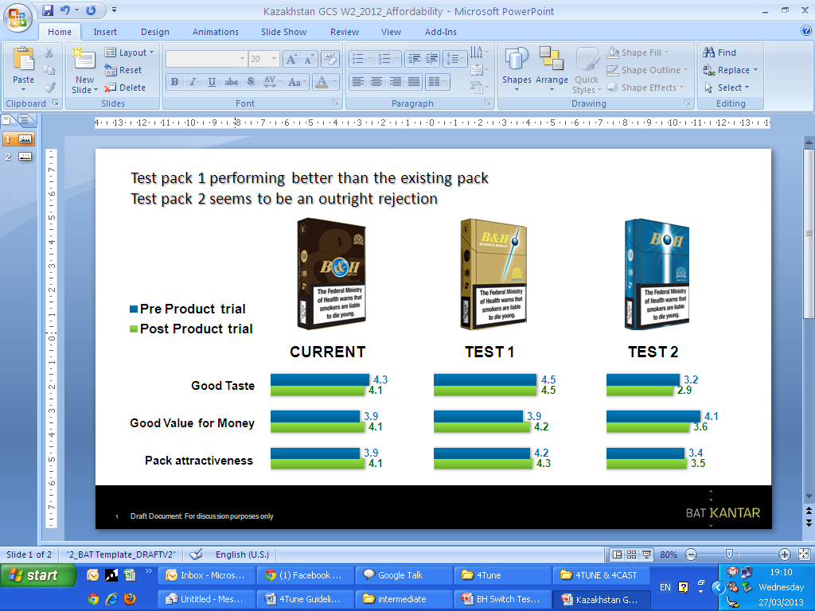

The key deliverable for the 4Tune Total Offer Test Dipstick will be a detailed diagnostics of the different mix elements, which will be able to identify how strong is the mix, and which are the elements that can potentially be improved.

# Agency for 4Tune

All 4Tune studies need to be coordinated by IMRB International. Fieldwork agency can be selected as per our normal process.